**Titanic Dataset Decision Tree**

**Importing the packages**

import pandas as pd

import numpy as np

from sklearn import tree

from sklearn import preprocessing

### Loading the dataset

titanic_train=pd.read_csv(‘train.csv')

titanic_train.head()

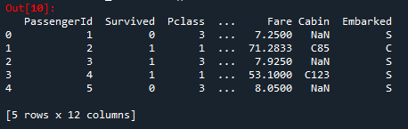

### Converting String to Int

l_enc = preprocessing.LabelEncoder()

titanic_train['Sex'] = l_enc.fit_transform(titanic_train['Sex'])

### Decision Tree

tree_model = tree.DecisionTreeClassifier(max_depth=3)

predictors = pd.DataFrame([titanic_train['Sex'],titanic_train['Age'],titanic_train['Fare']]).T

tree_model.fit(X = predictors,y=titanic_train['Survived'])

Out[16]:

DecisionTreeClassifier(ccp_alpha=0.0, class_weight=None, criterion='gini',

max_depth=3, max_features=None, max_leaf_nodes=None,

min_impurity_decrease=0.0, min_impurity_split=None,

min_samples_leaf=1, min_samples_split=2,

min_weight_fraction_leaf=0.0, presort='deprecated',

random_state=None, splitter='best')

with open('Dtree2.dot','w') as f:

f=tree.export_graphviz(tree_model,feature_names=['Sex','Age','Fare'],out_file=f)

tree_model.score(X=predictors,y=titanic_train['Survived'])

Out[18]: 0.796400449943757

### Model is accurate 79%

### Prediction

titanic_test = pd.read_csv('test.csv')

titanic_test.head()

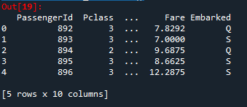

titanic_test.isna().sum()

Out[20]:

PassengerId 0

Pclass 0

Name 0

Sex 0

Age 0

SibSp 0

Parch 0

Ticket 0

Fare 0

Embarked 0

dtype: int64

titanic_test['Sex'] = l_enc.fit_transform(titanic_test['Sex'])

test_features = pd.DataFrame([titanic_test['Sex'],titanic_test['Age'],titanic_test['Fare']]).T

test_predict = tree_model.predict(X=test_features)

predicted_op = pd.DataFrame({'PassengerId':titanic_test['PassengerId'],'Survived':test_predict})

predicted_op.to_csv('output.csv',index=False)

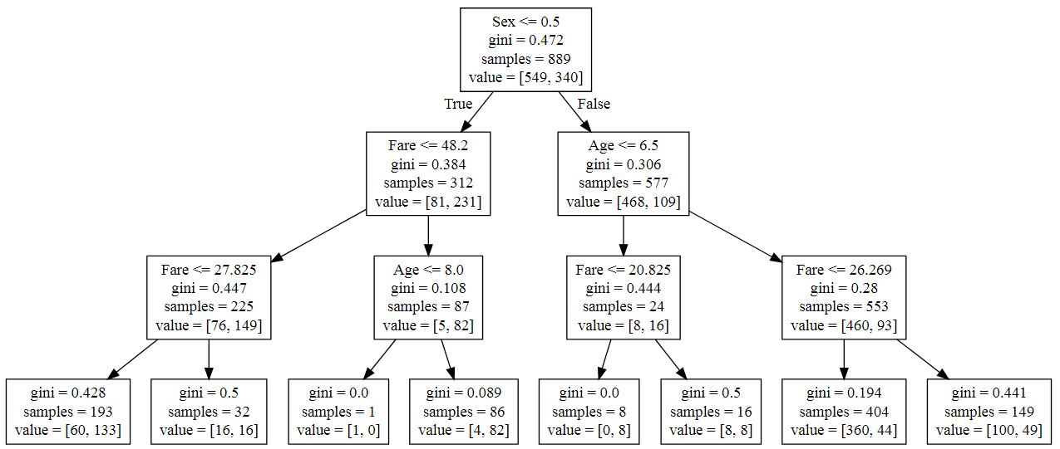

**Rules corresponding to given tree:**

1. **From total 889 samples 549 not survived and 340 survived.**
2. **Total 312 female, 81 female not survived and 231 female survived, and From 577 Male, 468 not survived and 109 male survived.**
3. **For female, if fair<=27.825 from total 225 samples 76 not survived and 149 Female survived.**
4. **For female, if age<=8.0 from total 87 samples 5 not survived and 82 Female survived.**
5. **For female, age<=8.0 , in one set only 1 not survived and 0 survived.**
6. **For female, Age>8.0 , from 86 samples 4 not survived and 86 survived.**
7. **For female, If fair>27.825 from 32 samples 16 not survived and 16 survived.**
8. **For male,if fair<=20.825 from total 24 samples 8 not survived and 16 survived.**
9. **For male,if fair<=20.825,total 8 Male survived.**
10. **For male,if fair>20.825,total 8 not survived and 8 Male survived.**